# Lesson 20 单词讲解

1. catch v. 抓到

catch fish

着火

catch fire

catch a bus

感冒了

catch a cold

catch caught caught

1. waste n. 浪费

It’s a waste of time / money / food.

v. 浪费

Don’t waste your time.

Wasting your time is wasting your life.

1. waste n. 浪费

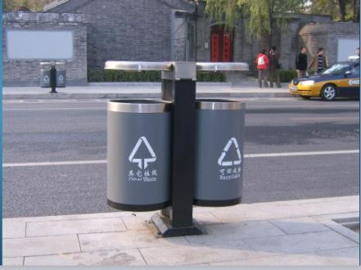recyclable

other waste

# Lesson 20 课文&语法讲解

动名词 doing

* 1. 作主语

(fish) is my favourite sport.

* 1. 介词后，作宾语

I often fish for hours without catching (catch) anything.

* 1. Some fishermen are unlucky. un-

unhappy unpleasant unimportant Uninteresting

介词后面跟：名词代词动名词 of 介词

* 1. Instead of catching fish, they catch old boots …

instead of …

catch fish

I am even less lucky

* 1. After having spent whole mornings …, I always go home with an empty bag.

After 是介词 后面跟着 动名词having

* 1. ‘You must give up fishing!’ my friends say.

Up 介词 后面加动名词，下面标绿色的 都是介词后面加动名词

* 1. must L17

give up sth./doing give up smoking

* 1. ‘It’s a waste of time.’
  2. I’m not really interested in fishing. be interested in …

And 是连接词 所以and 后面也得和in后面加ing一样

* 1. I am only interested in sitting in a boat and doing nothing at all !

# Lesson 20 知识拓展

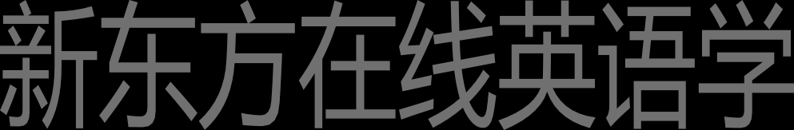本课重点:

doing 作主语／介词后作宾语

Playing is my favourite sport. Playing tennis is my favourite sport.

Playing tennis with my friends is my favourite sport.

Playing tennis with my friends every Sunday is my favourite sport. Playing tennis with my friends every Sunday is my favourite sport.

It is my favourite sport playing tennis with my friends every Sunday .

He sat there. He didn’t say anything. He sat there without saying anything.

She went out of the shop. (without) She didn’t pay the bill. She went out of the shop without paying the bill.

She was afraid. (of) She didn’t spend the night alone. She was afraid of spending the night alone.

Think carefully. (before) Answer my question. Think carefully before answering my question.

本课重点:

doing 作主语／介词后作宾语

